HEAT
THERMOMETRY
Temperature scale: A scale of temperature is one which can be used to measure the degree of hotness or temperature.
In order to set up a temperature scale, one selects some physical property, whose value changes with different degree of hotness.
Examples of physical properties used in different thermometers;
- Length of a liquid column ( a liquid – in – glass thermometer .
- Electrical resistance of a wire (platinum resistance thermometer).
- The pressure of a fixed mass of a gas at constant pressure (constant – pressure gas thermometer).
- Volume of the fixed mass of the gas at constant pressure (constant – pressure gas thermometer).
- E.M.F of a thermocouple (thermocouple thermometer).
- quality (wave length) of electromagnetic radiation emitted by a hot body (Pyrometers; optical pyrometer and total radiation pyrometer).

Qualities of a good thermometric property
- It should vary continuously and linearly with temperature changes.
- It should change considerably for a small change in temperature.
- It should vary over a wide range of temperatures.
- It should be accurately measurably over a wide range of temperature of fairly simple apparatus.
- Each value of thermometric property should correspond to one and only one value of the temperature.
Establishing of a temperature scale
- Choose a thermometric substance with a good thermometric physical property.
- Choose two fixed points i.e. upper and lower fixed points. For the Celsius scale, the lower fixed point is the ice point which is 0⁰c, and the upper fixed point is the steam point is 100⁰c. For the Kelvin scale, one fixed point is chosen i.e. triple point of water.
- The values of the thermometric property corresponding to the two fixed points are measured.

Let X_{L} and X_{u} represent the properties corresponding to the lower fixed point and upper fixed point respectively.
Assuming linear variation of the thermometric property.

X_{L}
X₀
X_{u}
Temperature

t_{l}
θ
t_{u}

The property X_{θ} at unknown temperature, θ is measured.
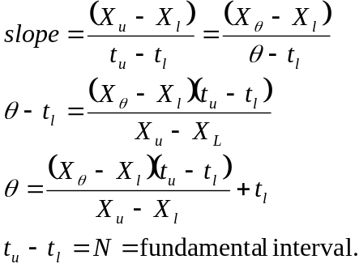

For the Celsius scale,
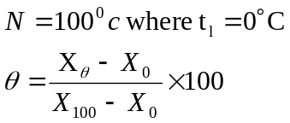

Examples of calculus scale defined on different thermometer
- Liquid in- glass thermometer (property is length, l.
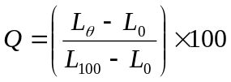
- Resistance thermometer (property is resistance, R)
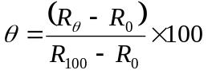
- Constant pressure gas thermometer (property is volume, V)
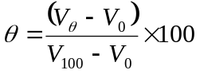
- Constant volume gas thermometer (property is pressure, P)
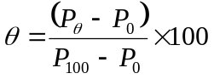
- Thermocouple thermometer (property is electromotive force, E)
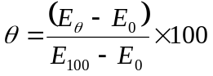

Mercury in glass thermometer
The thermometric property is the length L, of the mercury column. If L₁₀₀, L₀ L_{θ} are the lengths of the mercury column at the steam and ice points, and the unknown temperature, then,
Limitations of the mercury in glass thermometer are its freezing point (⁻39⁰c) and its boiling point at one atmosphere pressure (357⁰c)
Inaccuracies of the thermometer include;
- Non-uniformity of the bore of the capillary tube.
- Gradual creep of the zero due to the shrinking of the bulls long after manufacture.
- The mercury in the stem is not all the same temperature when taking a measurement..

Advantages of the mercury in glass thermometer
- They are simple, cheap and potable.
- They give direct readings of temperature.
Constant volume gas thermometer.

Bulb containing gas
Constant Volume mark
Mercury
Flexible rubber tubing
Dead space
h
c

A simple form of a constant volume gas thermometer is shown above.
The thermometer property is the pressure of the gas
The bulb is immersed in an ice – water mixture. Time is allowed for the air inside the bulb to assume the temperature of the bath. Tube C is moved downwards to bring the mercury level in the left hand cm to the constant volume mark.
The difference, h₀ in the mercury levels in the two arms is measured.
- Time is allowed for the air in the bulb to attain the temperature in the bath
- Tube C is allowed to bring the mercury in the left hand side to the constant volume mark. The difference h₁₀₀ between the mercury levels is measured.
- The bulb is then immersed in the system whose temperature is required.
- The difference in mercury levels, h_{θ} is determined as above
- The unknown temperature
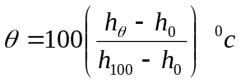
In a constant – volume gas thermometer there are a no. of source of error
These include.
- The temperature of the gas in the ‘dead space’ is different from that of the gas in the bulb.
- Thermal expansion of the bulb.
- Capillary effects at the mercury surfaces.

For accurate work, H₂ or Helium or N₂ gases are used. The gas thermometers are used as a standard to calibrate other more practical thermometers.
Disadvantages of the constant volume gas thermometers
Inaccuracies in measuring the heights.
- They are bulky
- They are slow to respond
- They do not give direct reading.
- Expensive to make.
- Can not be used to measure temperatures at points, only temperature of the air surrounding the bulb.
Advantages
- They have a wide range (-270⁰C to 1500⁰C).
- They are accurate.
- They are sensitive to any change in temperature.

The electrical resistance thermometer
It consists of a fine platinum wire is wound on two trips of mica, arranged cross wire as shown.
Mica strips
Leads
Platinum wire

Mode of operation
The platinum wire is connected in one cm of a whetstone bridge circuit shown below

R₂
R₁
G

S

r
R
r
Dummy leads

The resistance of the platinum wire is R. The resistance of the leads of the thermometer is r. Dummy leads which lie alongside the thermometer have resistance r. The thermometer is immersed in an ice water mixture and S is adjusted until the galvanometer G shows no deflection. Let S₀ be the value of S at balance
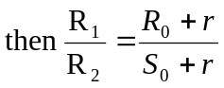
Where R₀ is the value of R at the ice-point. In the set up R₁ is made equal to R₂ hence R₀=S_{0.}
The resistance of the thermometer when it is immersed in a steam bath at 76cm of mercury is determined by adjusting S to obtain balance. Let S₁₀₀ be the value of S then. At balance, R₁₀₀ = S_{100.}
The thermometer is then immersed in the system whose temperature θ⁰c is required. S is adjusted to obtain balance. Let S_{θ} be the value of S then.
At balance R_{θ} = S_{θ.} the unknown temperature θ° is calculated from 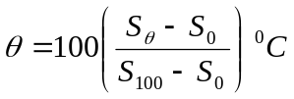
The range of the platinum resistance thermometer
The thermometer has a wide range of -200⁰c.
Advantages of the electrical resistance thermometer
- The single advantage of the electrical resistance thermometer is that is accurate. This is so because it is possible to measure resistance accurately.
- They can be used over a fairly wide range of temperature.
- It is used to measure steady temperatures.
Disadvantages of the electrical resistance thermometer
- A long time is needed for the thermometer to assume the temperature it is required to measure owing to the large heat capacity. This means that a long time is needed for making an observation.
- The thermometer cannot be used to measure temperature at a point.
Note. When calibrated against constant volume thermometers the resistance R of platinum is found to vary with Celsius thermometer θ according to
Where R₀ is the resistance of the platinum at 0⁰c and α and  are constants. The values of R₀, α and for a given platinum resistance thermometer can be found by measuring its resistance at the ice point, steam point and boiling point of sulphur and inserting the values into equation (1).

Thermocouples
Suppose wires A and B of different materials are joined to make junctions 1 and 2 as shown
G
B
B
1
2
A

If the temperature of the junction 1 is raised above that of junction 2, the galvanometer G shows a deflection implying that an emf has been generated. This emf is called a thermoelectric emf. The magnitude of the emf varies with the temperature difference between the two junctions. This is the basis of measurement of temperature using a thermocouple.
The test junction is immersed in a steam bath at one atmosphere pressure and the corresponding thermoelectric emf E₁₀₀ measured.
The test junction is immersed in the system whose temperature is required. The corresponding thermoelectric emf E_{θ} is measured.
The unknown temperature, 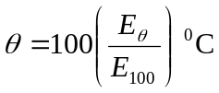

Advantages of a thermocouple
- Wide range of temperature i.e. ⁻250⁰c to 1500⁰c
- It has a small heat capacity, hence it can be used to measure rapidly changing temperatures.
- It can measure temperatures at a point.
- Thermocouples can robust and compact. They are cheap and easy to construct.
- It can be used for measuring low temperatures since the emf generated is small.
Disadvantages of thermocouple
Each thermocouple requires separate calibration.

The thermo Dynamic scale of temperature
This is the fundamental temperature scale in science and uses the Kelvin, K as the SI unit of temperature. It uses the triple point of water as the standard fixed point. Triple point is the temperature at which pure water, pure melting ice and saturated vapour pressure exist in equilibrium.
The temperature of the triple point of water is given the value 273.16k.
Let X_{tp} be the thermometric property at the triple point of water and X_{t} the thermometric property at the unknown temperature, T. Then
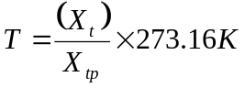
The magnitude of a degree, on the Celsius scale is equal to the magnitude of a degree on the thermodynamic scale. If θ denotes temperature on the Celsius scale, and t the temperature on the thermodynamic scale then, t = θ + 273.16

Radiation pyrometers
A radiation pyrometer is an instrument used to measure the temperature of a body by the radiation that the body emits. They are best suited for measuring temperatures above 1000⁰c . Radiation pyrometers are of two types;
- Total radiation on pyrometer. These respond to both visible and infrared radiation
- Optical pyrometer- these respond only to visible radiation.

Optical pyrometer
A typical optical pyrometer is the disappearing filament pyrometer. This consists of a refracting telescope having a tungsten lamp filament at the focus of its objective as shown below.

A
F
eyepiece
Eye
filament
Hot body

The observer looks through the red filter F at the filament against a background formed by the image of a small area of the body. If the image of the hot body is brighter than the filament, the filament will appear dark on a bright background. If the filament appears bright on the dark background i.e. hot body is then less bright than the filament. Current through the filament is adjusted until the filament “disappears”. The ammeter A, calibrated to read temperature, will give the temperature of the hot body. The range of pyrometer is up to 300⁰C.

Examples:
1. In a constant volume gas thermometer the following observations were recorded on a day when the volumetric reading was 760mmHg.

 | Reading in the closed limb (mm) | Reading in the open limb (mm)
Bulb in melting ice | 126 | 112
Bulb in steam | 126 | 390
Bult at room temperature | 126 | 157

Calculate the room temperature
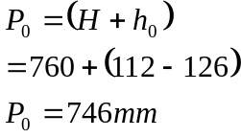

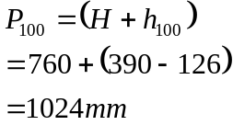

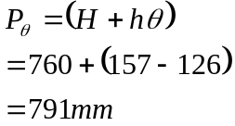
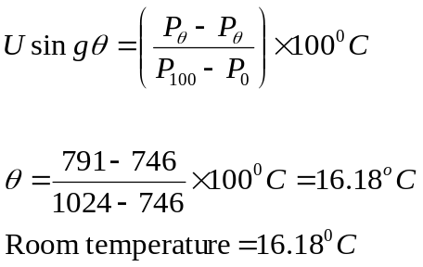
2. The resistance of platinum thermometer is 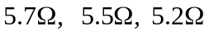 at boiling point, unknown temperature, θ, and at the freezing point of water respectively. Determine the unknown temperature in θ°C.
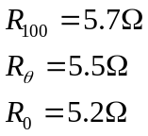
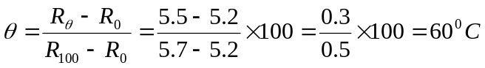

3. The resistance R_{θ} of a platinum thermometer at a temperature at a temperature θ⁰C on a gas thermometer is
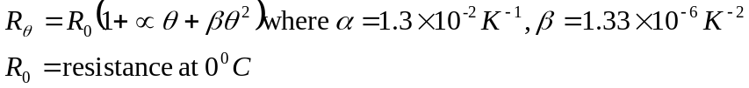
Calculate the temperature of the resistance thermometer when temperature on the gas thermometer is 300⁰C
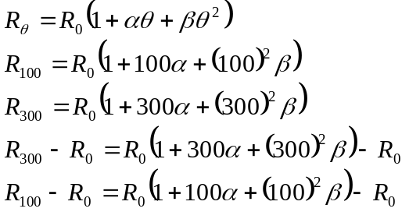
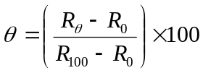
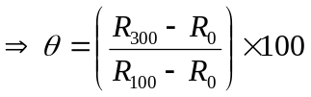
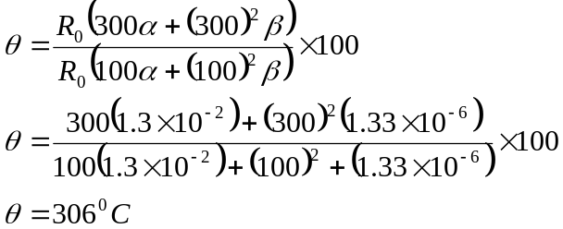
Exercise
1. If the resistance R_{t} of the element of a resistance thermometer at a temperature of t°C on the ideal gas scale is given by R_{t} = R_{o}(1 +At + Bt²), where R_{o} is the resistance at 0°C and A and B are constants such that A = - 6.50x10³B, What will the temperature on the scale of resistance thermometer when t = 50.0°C? (50.4°C)
2. The resistance of a platinum resistance thermometer is 4.00Ω at the ice point and 5.46Ω at the steam point. What temperature on the platinum resistance of 9.84Ω? (400°C)
3. The resistance of platinum wire at the triple point of water is 5.16Ω. What will its resistance be at 100°C? (7.05Ω)

SPECIFIC HEAT CAPACITY
Specific heat capacity is the amount of energy required to raise the temperature of 1kg mass of as body by 1k. Its unit is Jkg⁻¹K⁻¹.
The quantity mass times the specific heat of the substance is called the heat capacity. Its unit is JK⁻¹
Measurement of specific heat capacities
Using method of mixtures
A calorimeter is weighted empty and its mass, m_{c} recorded.
The calorimeter is then half – filled with water and weighted again to determine the mass of water m_{w} added. The temperature θ₁ of the water and calorimeter is measured after thorough stirring.
The mass m_{s} of the specimen solid is determined. The specimen is heated to a temperature, θ₂. The specimen is then quickly transferred into the water in the calorimeter. The temperature θ₃ reached by the mixture is determined.
Continuous stirring during the mixture must be ensured.
Assuming that all heat lost by the specimen is gained by the calorimeter and the water, then
Where c_{s}= Specific heat capacity of the specimen,
c_{w} = Specific heat capacity of water,
c_{c} = Specific heat capacity of material of the calorimeter
Thus 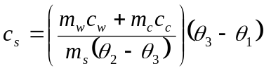
Precaution
- Ensure that the specimen does indeed reach the temperature θ₂
- The specimen must be transferred into the calorimeter as fast as possible but carefully so as to avoid splashing water out of the colorimeter.
- The colorimeter must be placed on insulating stands in a constant temperature jacket.
- The calorimeter must be highly polished on the outer surface and the jacket on the inner surface to reduce heat loss by radiation.
- The lid reduces heat law by convection.
- Stirring while the temperature of the mixture is raising must be ensured.

Cooling correction in the method of mixtures
In the method of mixtures in determining specific heat capacity, a hot body is placed in a liquid at lower temperature. Consequently, the temperature of the liquid rises above that of the surroundings. In the process, heat is lost to the surroundings. The observed final temperature is lower than it would have been if no heat had been lot to the surroundings.

Theoretical curve
Experimental curve
Time
∆θ
Θ₃¹
Θ₃
Θ₁
0

Δθ is the cooling correction
θ₃ is the observed temperature of mixture
θ₃¹ is the true final temperature of mixture
The cooling correction is the small temperature added to the observed final temperature of the mixture to compensate for heat lost to the surroundings, while the temperature of the mixture was rising.
A cooling correction is normally carried out when determining specific heat capacity of a bad conductor, such as rubber, by method of mixtures.
Question: Why should a cooling not applicable for good conductors?

Obtaining a cooling correction for a poor conductor of heat:
A known man of water m_{w} is placed in a container of known mass m_{c}. The temperature θ₁ of water is recorded. A rubber bung is weighed and its man m_{s} recorded. The bung is placed in boiling water and left in for sufficiently long for it to attain the temperature θ₂ of the boiling water.
The rubber bung is removed from the boiling water, shaking off the water drops dinging to it and is quickly transferred into the calorimeter.

The temperature θ, of the mixture, is recorded every half minute. A graph of temperature θ against time is plotted.

A
∆θ
B
C
D
A₁
A₂
θ₁
Θ₃
θ°C
q
time

AB is drawn through the top of the cure parallel to the temperature axis and CD further along the curve. The areas A₁ and A₂ are estimated by counting the squares on the graph paper. Cooling correction is therefore, 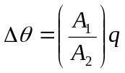
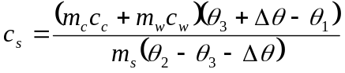

Determination of specific heat capacity of a liquid by the continuous flow method.
V
A
Liquid from tap
Heating coil
P₂
P₁
Liquid out
Liquid in
Constant head apparatus

In the figure above, P₁ and P₂ are platinum resistance thermometers. The rate of flow of liquid through the apparatus is adjusted to suitable value by raising or leveling the constant head apparatus. The electric circuits connected up. Time is allowed for the thermometers P₁ and P₂ to record steady temperatures θ₁and θ₂ respectively, are then recorded.
Water is collected at the outlet in a previously weighed beaker for a measured time. The rate, m₁ of flow of water is recorded. The ammeter and voltmeter reading I₁ and V₁ respectively are recorded. The constant pressure head is raised to obtain a new rate of flow. The current flowing is adjusted so as to keep (θ₂- θ₁) constant. The ammeter and voltmeter reading I₂ and V₂ respectively are recorded. The new rate m₂ of the flow of water is measured.
In the first part of the experiment
I₁V₁ = m₁c(θ₂ – θ₁) + h……………………………………………. (i)
Where c is the specific heat capacity of liquid, h is the small rate of loss of heat to the surroundings.
In the 2nd part of the experience
I₂V₂ = m₂c(θ₂ - θ₁) + h……………………………………………….. (ii)
Note that the rate of loss of heat to the surroundings is the same in both experiments since the excess temperature above the surroundings is the same ( See Newton’s law of cooling later).
Hence; equation (i) – equation (ii)
c = I₁V₁ – I₂V₂
(m₁ – m₂) (θ₂ – θ₁)

Advantages of the method
1. The temperatures are measured are steady and therefore can be determined accurately by using platinum resistance thermometer.
3. The heat capacity of the apparatus does not have to be known.
4. According correction is eliminated by a repeat experiment.
5. Since temperatures are steady, small temperature differences can be used. Hence the method can be used to investigate the temperature dependence of the specific heat capacity of a liquid.

Disadvantage
1. A large quantity of liquid is required.
2. Only limited to liquid

Questions
1. In a determination of the specific heat capacity of rubber, by the method of mixtures, this data was obtained
Mass of calorimeter = 44.70g.
Mass of water in the calorimeter = 70.33g
Initial temperature of the rubber stopper = 96.5°C.
The temperature of the mixture was read and recorded every minute and the following results were obtained
Time (mm) | 0.0 | 1.0 | 2.0 | 3.0 | 4.0 | 5.0 | 6.0 | 7.0 | 8.0 | 9.0 | 10.0
Temp. of the mixture | 30.5 | 34.5 | 35.5 | 36.0 | 36.5 | 36.3 | 36.0 | 36.0 | 35.9 | 35.6 | 35.4

i) Plot a graph of temperature of the mixture versus time
ii) Use the graph to determine the cooling correction (0.6K)
  - Calculate the specific heat capacity of the rubber ( 1.28x10³Jkg⁻¹k⁻¹)
(Specific heat capacity of water = 4.2 x 10³ JKg⁻¹k⁻¹)
(Specific heat capacity of copper = 3.8x 10² JKg⁻¹K⁻¹)
(Mass of rubber stopper = 27.05g).

1. A copper colorimeter of mass 0.30kg contains 0.50kg of water at a temperature of 15ºC. A 0.56kg block of copper at a temperature of 100ºC is dropped into the colorimeter and the temperature is observed to increase to 22.5ºC. Find the specific heat capacity of copper.
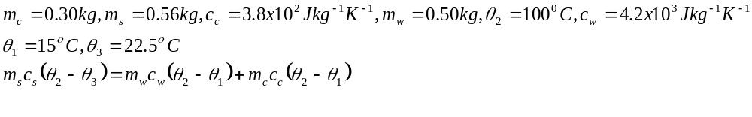
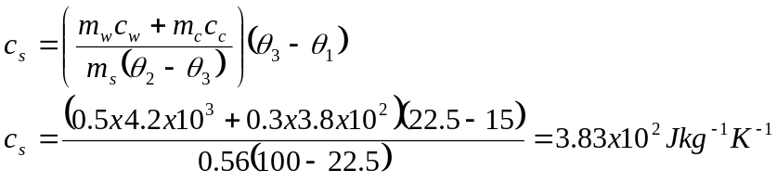

2. In a continuous flow experiment it was found that when the applied p.d was 12.0V, the current was 1.54A, the rate of flow of liquid of 50g per minute caused the temperature of the inflow to differ by 10°C with temperature of inflows. When the p.d was increased to 16.0V (the current of 1.6A) a rate of flow of 90.0g per minute was required to produce the same temperature difference as before. Find the specific heat capacity of the liquid and the rate of heat loss.
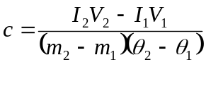
In continuous flow colorimeter for measurement of specific heat capacity of a liquid, 3.6 x 10⁻³m³ of liquid flow through the apparatus in 10 minutes. When electrical energy is supplied to the heating coil at the rate of 44W, a steady difference of 4K is obtained between the temperatures of the outflow and inflow. When the flow rate is increased to 4.8 x 10⁻³m³ of liquid in 10 minutes, the electrical power required to maintain the temperature difference is 58W. Find the;

- Specific heat capacity of the liquid (2187.5JKg⁻¹K⁻¹)
- Rate of loss of heat. (2W)
(Density of the liquid = 800kgm⁻³)

4d) An electric drill takes 300s to make a hole in a piece of brass of man 9.5kg and the average power delivered from the mains in 45w.

- Calculate the amount of energy used in drilling the hole.
- If 80% of the energy supplied to the drill is used to raise the temperature of the brass.
Calculate the average temperature rise. State any assumption made.
(S.H.C of brass = 390JKg⁻¹K⁻¹).

NEWTON’S LAW OF COOLING
The rate of loss of heat by a body is proportional to the excess temperature over the surrounding.
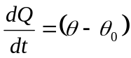
Where θ = Temperature of body.
θ_{o} = temperature of surrounding

Experiment of verify Newton’s law of cooling.
A colorimeter is filled with hot water initially at the temperature of about 90°C is placed in an air draught near a window and its temperature θ measured every ½ a minute.
Thermometer
Stirrer
Stop Clock

A graph of θ against time, t is plotted and is called a cooling cure.
θ₀
θ
dθ
dt
t

Where θ₀ is the room/surrounding temperature
Tangents are drawn at different points of the curve and the slope of the tangents are the rate of fall of temperature,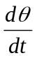 are determined
A graph of against excess temperature (θ- θ_{o}) is plotted.

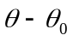

From the graph, we can say that 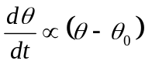
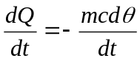
where m = mass of liquid.
C is the specific heat capacity
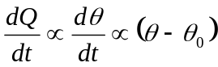
Hence 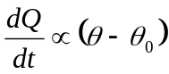
In general, the above relation is given by;
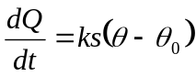
where s = surface area of body losing heat, k is a constant which depends on the nature of the surface.
The mass of body is proportional to its volume.
The rate of heat loss however is proportional to surface area of the body. Therefore, the rate of fall at temperature is proportional to ratio of surface to volume of body.

For bodies of similar shape, the ratio of surface to volume is inversely proportional to any linear dimension
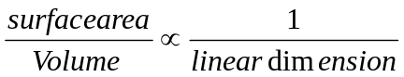
If the bodies have surfaces of similar nature, the rate of fall of temperature is inversely proportional to linear dimension. A small body cools faster than a large one. A tiny baby should be more thoroughly wrapped up than a grown man. In calorimeter, the fact that a small body cools faster than a larger one i.e the larger the specimen, the less serious is the rate of loss of heat, large calorimeter are normally used to reduce loss of heat to the surrounding.

Latent heat

Melting: When a solid is heated, the amplitudes of vibration of the atoms increase. Then the amplitude of vibration exceeds article fraction of the atomic spacing, the regular arrangement of the atom in the solid collapses and the liquid is said to melt. At the melting point, the solid and liquid form exists in thermal equilibrium with each other. The energy required to break the bands holding the atom in a rigid lattice is the latent heat of fusion.
Specific heat of fusion.
The energy required to change one kilogram of a solid into liquid at its melting point is the specific latent heat of fusion (L).
Note: If the solid has to be given energy to melt it, then that energy must be given out when the liquid freezes.
Determination of specific latent heat of ice by the method of mixtures
Constant temperature enclosure
Stirrer
Thermometer

Small chips of ice are added one by one and the water stirred until each piece has melted before the next is added. When the temperature of the water as fallen by as much as the water was above room temperature, the final temperature θ_{f} is measured and recorded.
The calorimeter and contents are weighed again and the mass m_{i} of ice added, calculated.
Theory of the method
Heat lost by the water and calorimeter in cooling from
Θ₁ to θ_{f} is (M_{c}C_{c} + M_{w}C_{w}) (θ₁– θ_{f})
Where C_{c} and C_{w} are the specific heat capacities of the calorimeter and water respectively.
Heat gained by ice = m_{i} L+ m_{i} C_{w} θf
Where L = latent heat of fusion of ice.
Assuming no heat is lost to the surrounding.
(M_{c}C_{c} + M_{w}C_{w}) (θ₁– θ_{f}) = m_{i} L+ m_{i} C_{w} θ_{f}

Hence 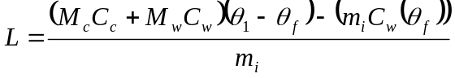

Determination of specific latent heat of fusion of ice by an electrical method.
A
V
R
K

Ice of has been pressed between bloating papers is packed in the funnel, and the funnel and the heating coil submerged unit. Switch K is closed and a clock started. A beaker of known mass is placed below the funnel to collect the water produced when the ice melts.
When sufficient ice has melted, the clock is stopped. The beaker is weighed to determine the mass of water, m₁.
Assuming no heat losses to the surrounding;
Electrical energy supplied = energy used to melt the ice.
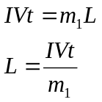
Specific Latent heat of vaporization:
It is the amount of heat required to convert 1kg mass of a liquid to vapour at its boiling point.

Measurement of specific latent heat of vaporization of a liquid.
Determination of specific latent heat of vaporization. of by method of mixtures
Heat
Shielding
Stirrer
Constant temperature jacket
Calorimeter
Thermometer
Boiling water

A calorimeter of known mass, m_{c} is half filled with cold water. The mass m_{w} of the water is determined. The temperature θ₁ of the water is measured, after thorough stirring. The calorimeter is placed a constant temperature jacket as shown below.
The temperature θ_{s} of the steam is recorded. Steam is blown onto the surface of the water in the calorimeter until a temperature rise of about 30ºC is obtained. The temperature θ_{f} of the water is measured after thorough stirring. The calorimeter and contents are weighed a gain to determine the mass of steam condensed.

Theory of method.
Heat lost by steam in condensing and cooling to a temperature θ_{f} is
M_{s}L_{v} + M_{s}C_{w} (θ_{b} – θ_{f})
Where θ_{b} is the boiling point of water
Heat gained by the colorimeter and water = (M_{c}C_{c} + M_{w}C_{w}) (θ_{f} – θ₁)
Where Cc and C_{w} are the specific heat capacities of the calorimeter and water respectively.
Assuming no heat losses to the surrounding.
(M_{c}C_{c} + M_{w}C_{w}) (θ_{f} – θ₁) = M_{s}L_{v} + M_{s}C_{w} (θ_{b} – θf)
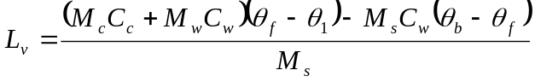

Determination of specific latent heat of vaporization by an electric method
Cold water in
Felt lagging
Warm water out
V
A
H
Condensed water
liquid under investuigation
Dewar flask
H
K
T

The specimen liquid is heated to boiling point by the heating coil, R, Shown above. The vapour passes by the holes H down tube T and is condensed by the water jacket K. When the apparatus has reached steady state (with the liquid boiling and the temperatures of the apparatus steady), liquid emerging form T is collected in a previously weighed beaker for a measured time t.
The mass rate m₁ of vapour of condenses in time t is found. The readings I₁ and V₁ of the ammeter and voltmeter respectively are recorded.

In the steady state, the electrical energy supplied is used to evaporate the liquid and to offset losses.
Thus I₁V₁ = m₁L_{V} + h ………………………………….. (1)
Where h is the rate of loss of heat to the surrounding
The current and voltage are adjusted to obtain a new rate of evaporation. The mass rate, m₂ of vapour which condenses in the same time t is determined. Let I₂, V₂, be the new values of current and voltage.

Then I₂V₂ = m₂L_{V} + h (2)
since the rate of loss of heat is constant as the temperature excess above the surrounding is constant, from equation (1) and (2).
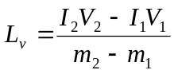
Examples,
1. Water in a vaccum flask is boiled steadily by a coil of wire immersed in the water. When the p.d across the coil is 5.25V and the current through it in 2.58A, 6.85g of water evaporates in 20minutes. When the p.d and the current are maintained at 3.20V, 1.57A, 2.38g of water evaporate in 20 minutes. Calculate the specific latent heat of vaporization of water.
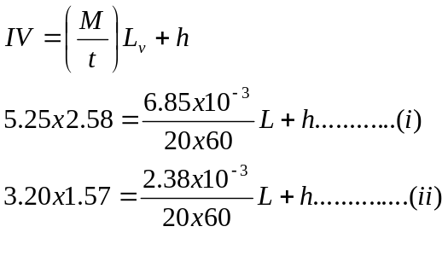
Equation (i) – equation (ii)
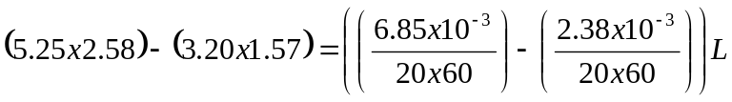
Hence L = 2.29x10⁶JKg⁻¹
2. A stream of election each of mass 9.0x10⁻³¹ kg and velocity 2.0x10⁷ ms⁻¹ strikes
5 x 10⁻⁴kg of silver initially at 20ºC mounted in a vacuum. Assuming 10⁶ elections strike the silver per second, and that all their energy in converted into heat which is retained by the silver, calculate the time taken for the silver to melt.
Specific heat capacity of silver at 20ºC = 2.35 x 10 JKg⁻¹K⁻¹, melting point of silver = 960ºC.
Specific latent heat of fusion of silver = 1.09x10⁴ JKg⁻¹
Solution
Kinetic energy of the electron, = ½mv² = ½ x 9.0 x 10⁻³¹ (2x 10⁷) x 10¹⁶Js⁻¹ = 1.8Js⁻¹
Heat required to melt the silver = 5 x10⁻⁴ x2.35 x10²x(960-20) + (5 x10⁻⁴) x 1.09x10⁴
= 115.9J
Let the time taken to melt the silver be t seconds.
1.8t = 115.9
t = 64.45
Exercise
1. An aluminum pail of man 1.5kg contains 1kg of water and 2 kg of ice at 0°C. If 3 kg of water at 70°C is poured into the pail, calculate the final temperature of the pail water.(7.9°C)
Specific heat capacity of aluminum = 910 JKg⁻¹K⁻¹
Specific heat capacity of water = 4.2 x10³ JKg⁻¹K⁻¹
Specific latent heat of fusion of ice = 3.36 x 10⁵ JKg⁻¹
2. When electrical energy is supplied at a rate of 12.0W to a boiling liquid, 1.0x10⁻² kg of liquid evaporates in 30 minutes. On reducing the electrical power to 7.0w, 5.0x10⁻³kg of the liquid evaporates in the same time. Calculate;
- The specific latent heat of vaporization of the liquid (1.91x10⁶ JKg⁻¹)
- The power loss of the surroundings.(1.4W)
- A well lagged copper calorimeter of mass 100g contains 200g of water and 50g of ice at 0°C. Steam at 100°C, containing condensed water at the same temperature is passed into the mixture until temperature of the calorimeter and its content is 30°C. If the increase in mass of the calorimeter and contents is 25g, calculate the percentage of condensed water in stem. (25.6%)
Specific heat capacity of water = 4.2 x10³ JKg⁻¹K⁻¹
Specific latent heat of fusion of ice = 3.34x 10⁵ JKg⁻¹
Specific latent heat of vaporization of water = 2.26x 10⁶ JKg⁻¹
Specific heat capacity of copper = 400JKg⁻¹K⁻¹

- An electrical heater rated 500W is immersed in a liquid of mass 2kg contained in a large thermo flask of heat capacity 840Jk⁻¹ at 28°C. Electrical power is supplied to the heater for 10minutes. If the specific heat capacity of the liquid is 2.5x10³ Jkg⁻¹K⁻¹, its specific latent heat of vaporization is 8.4x10³JKg⁻¹ and its boiling point is 78°C, estimate the amount of liquid which boils off. ( 0.94kg)
- Ice at 0°C is added to 200g of water initially at 70°C in a vacuum flask. When 50g of ice has been added and has all melted, the temperature of the flask and content is 40°C. When a further 80g of ice has been added and has all melted, the temperature of the whole becomes 10°C. Calculate the specific latent heat of fusion of ice, neglecting any heat lost to the surroundings. (3.78x10⁵Jkg⁻¹) Use the constants in question 4

EXPANSION IN GASES AND GAS LAWS

Gas laws
Boyle’s law: The volume of a fixed mass of gas is inversely proportional to pressure at constant temperature.
VP = constant.
Or 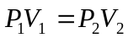
Charles’ law
The volume of fixed mass of gas at constant pressure is directly proportional to absolute temperature at constant pressure
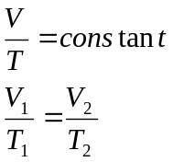
The pressure law
The pressure of a fixed mass of a gas is directly to absolute temperature provided volume is constant.
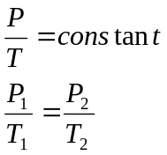
Question: Describe the experiments to verify the above laws.

General ideal gas law.
Consider a fixed mass of an ideal gas taken through the stages shown below.
V₁,T₁
P₁
V,T₂
P₁
V₂,T₂
P₂
P₁ constant
T₂ constant

When the gas changes at constant pressure
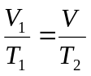……..(1)
When the gas at constant temperature T₂
From equation (1) 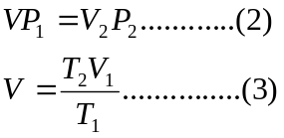Substitute equation (3) into (2)
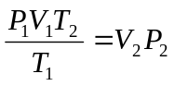
Hence 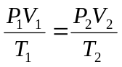
There fore 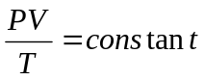
Or 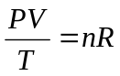
Where R is called the \universal gas constant, and n the number of moles of the gas.

Question:
1. In an experiment the pressure of a fixed mass of air at constant temperature is 10.4kpa.
When the volume is halved, keeping temperature constant, pressure becomes 19.0Kpa.
Discuss the applicability of the above result in verifying Boyle’s law.
2. Two cylinders A and B of volumes V and 3V respectively are separately filled with gas. The cylinders are connected as shown with the top closed. The pressure in A and B are P and 4 P respectively. When the tap is opened, the common pressure becomes 60kPa.
Assuming isothermal conditions, find the value of P.
A
B
Tap

Initially in A
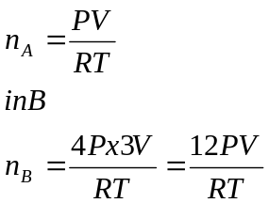
After opening
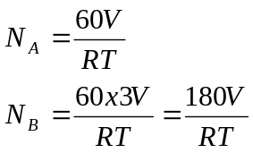
Given that the number of moles remains constant
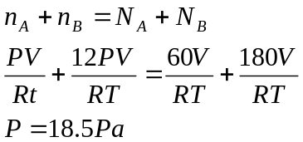

2. A column of air 10cm long is trapped in a horizontal uniform capillary tube by mercury thread 8cm long, one end of the tube being closed and the other end opened to the atmosphere. If the atmospheric pressure is 76cmHg, find the length of air when the tube is placed vertically with its open end upwards.
When the tube is horizontal
8cm
10cm
P_{a} = 76cmHg

P₁ = 76cmHg, V₁= 10Acm³, where A is the cross section area.

When the tube is vertical
8cm
L cm
P_{a} = 76cmHg

P₁ =(76 +8)cmHg = 84cmHg, V₁= LAcm³, where L is the length of the air column.
Using Boyle’s law
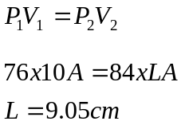
Exercise
1. A narrow uniform glass tube contains air enclosed by a thread of mercury 15cm long. When the tube is vertical with the open and uppermost, the column is 30cm long. When the tube is inverted, the length of the column becomes 45cm long. Calculate the value of the atmospheric pressure. (75cmHg)
2. A Uniform narrow bored tube closed at one end contains some dry air with is sealed by a thread of mercury 15cm long. When the tube is held vertically with the closed end at the bottom, the air column is 20cm long, but when it is held horizontally, the air column is 24cm long. Calculate the atmospheric pressure.
3. Two bulbs A of volume 100cm³ and B 50cm³ are connected to a three way top which enables them to be filled with gas or evacuated. The volume of the tubes may be neglected. Initially bulb A is filled with an ideal gas at 10°C to a pressure of 3.0 x10⁵Pa. Bulb B is filled with an idea gas at 100°C to a pressure of 1.0x10⁵Pa. The two bulbs are connected with A maintained at 10°C at B at 100°C. Calculate the pressure at equilibrium. (2.45 x 10⁵ Pa.)

KINETIC THEORY OF GASES
Assumptions/postulates made in Kinetic theory of ideal gases
1. Molecules in a container are always randomly moving about, continuously colliding with each other and with the walls of the container.
2. Collisions between the molecules and the walls of the container are elastic
3. The intermolecular forces (repulsive and attractive) are negligible.
4. The volume of the molecules themselves is negligible compared with the volume of the container.
5. The duration of collision (i.e. time the molecule spends in contact with the wall) is negligible compared with the time spent by a molecule in collision.

Calculation of the pressure of an ideal gas.
Consider a large number N, of molecules of a gas each of mass contained in a cubical box of length l.
u
v
w
x
y
z
X
l
l

Let c be the velocity of a molecule at some instant with components u,v,w a long X,Y and Z axis.
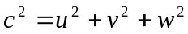
Consider the molecule colliding with the wall X at right angles
The change in momentum on impact = -mu-mu
= -2mu

If t is the time taken for the molecule to more across the cube to the opposite face and back to the wall X, 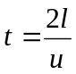
Hence the rate of change of momentum at X will be
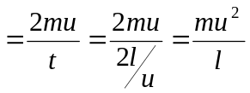
hence the force exerted by the molecule on the wall X,
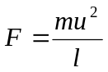
Pressure on X due to one molecule =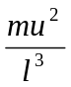
For N molecules moving with speeds 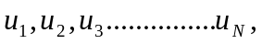the total pressure exerted on the wall X is given by
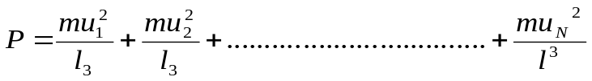
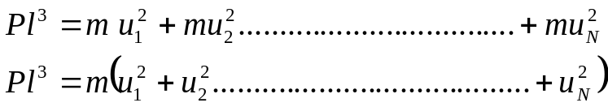
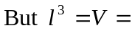volume of the cube
If 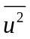is the mean value of the square of the X – component of velocity
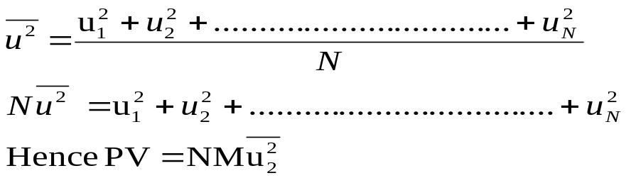
Since the molecules are moving randomly in the container, there is no preference for moving parallel to any axes.
Hence 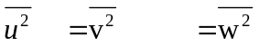
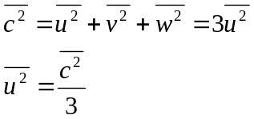
From PV=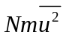
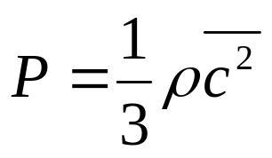
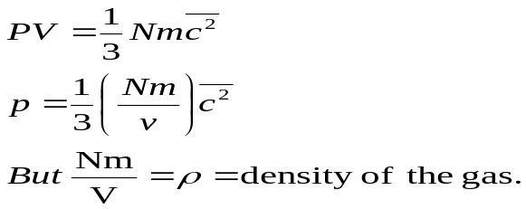

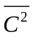 means square value of the velocity of the gas.
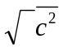= root mean square value of the speed of the gas.

Interpretation of absolute temperature
From Kinetic theory 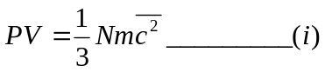
For an ideal gas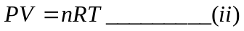
From (i) and (ii)
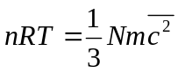

For 1 mole of a gas
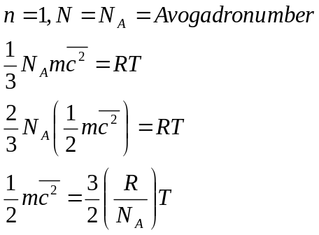
But 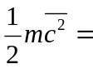 mean K.E of translational per molecule
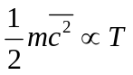
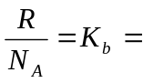 Boltzmann’s constant
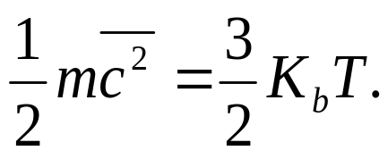

Kb = 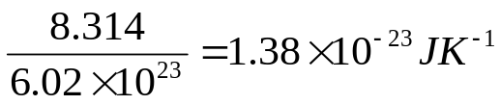

But N_{A}m = M = Molecular mass of the gas

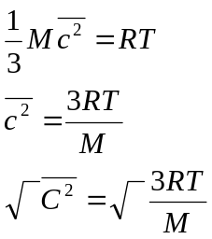

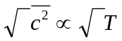
Hence 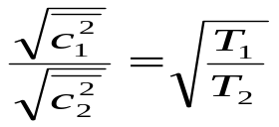

Examples
Calculate root mean square of the molecule of an ideal gas at 127⁰C given that the density of the gas at a pressure of 1.0x 10⁵ Nm⁻² and temperature 0⁰C is 1.43kgm⁻³.
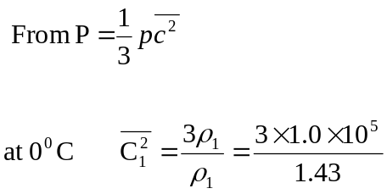
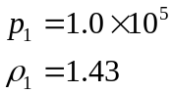

127⁰C = 400k
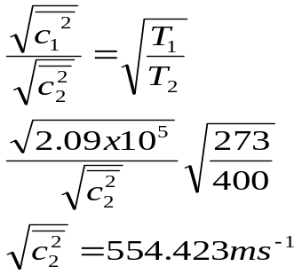

Deduction from Kinetic theory
Avogadro’s hypothesis: Equal volumes of gases at the same temperature and pressure contain the same no. of molecules. Consider two different gases of equal volume at the same temperature and pressure.
Gas 1 Gas 2
P,V,m₁,

c₁, N₁
P,V, m₂,

c₂, N₂

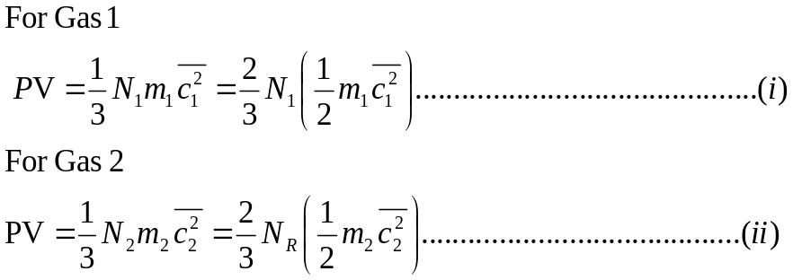
If the two gases are at the same temperature.
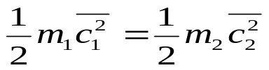
Hence
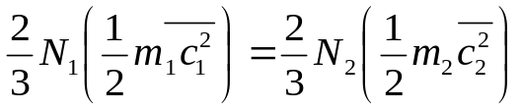
Hence 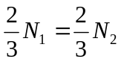
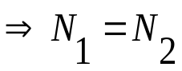

2. Dalton’s law of partial pressures
Partial pressure of a gas is the pressure a gas would occupy if it occupied the whole container alone.
The law states that the total pressure of the mixture of gases is equal to the sum of the partial pressure of the constituent gases
Suppose a cylinder
P₁, V₁, T

N₁, m₁, c₁
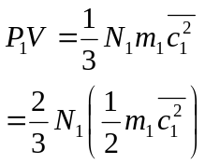
Gas 1 is removed and replaced by gas 2
P₂, V, T

N₂, m₂, c₂
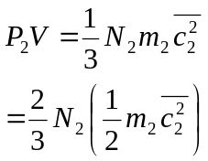
If the two gases are mixed
P, V,

N, m, c

Where m is the mean mass per molecule
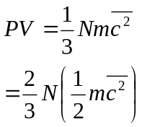
If the gases are mixed at constant temperature;
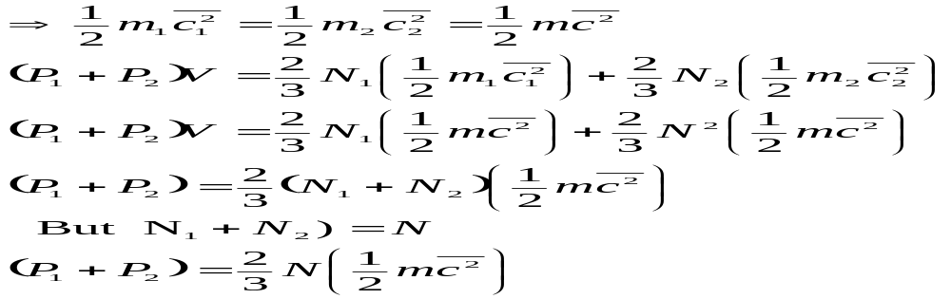
But
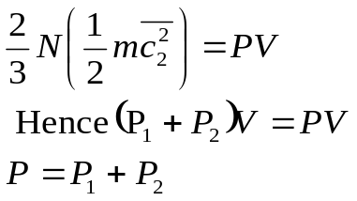

Boyle’s law
From Kinetic theory
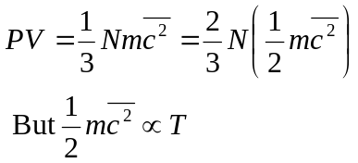

If the temperature is kept constant, then
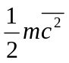 is constant

Hence 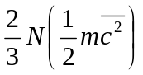is constant term

Therefore PV = constant

Charle’s law
From Kinetic theory 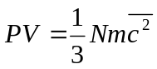
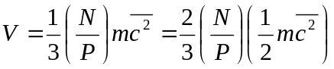

For a fixed mass of gas kept at constant pressure 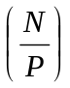= constant
But
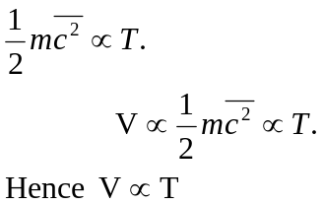

Pressure law
From Kinetic theory
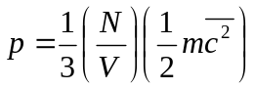

For a fixed mass of gas at constant volume 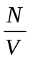= constant

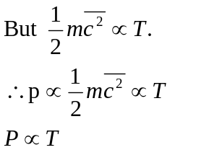

Real gases and Vander Waal’s forces
The general equation of state: 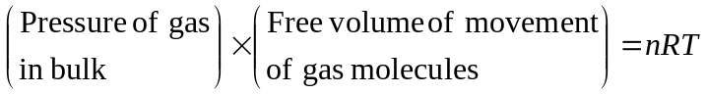
For ideal gases, the attractive forces are ignored and the pressure in the bulk of the gas is equal to the pressure P at the walls, and since the repulsive forces are ignored, the volume of the molecules themselves is also ignored hence the free volume of movement of the molecules is equal to the volume V of the container.
Hence the equation of state of an ideal gas is
PV = nRT
For real gases, the following assumptions of the Kinetic theory have to be modifies
- Intermolecular forces are negligible.
- The volume of the molecules themselves is negligible.
Due to the repulsive forces in real gases, molecules have a particular volume and hence can not be compressed indefinitely. Surrounding each molecule, there is a definite volume called co-volume which can not be occupied by any other molecule, therefore the free volume of movement of the molecule is (V-b) where V is the volume of the container and b is a factor which depends on the co-volumes of the molecules.

Due to the attractive forces, molecules approaching the walls of the container are attracted by the bulk molecules. This would reduce the momentum of the bombarding molecules thereby reducing the pressure exerted on the walls. The pressure P exerted at the walls is less than the pressure in the bulk.
Pressure in bulk = pressure at the wall (p) + pressure defect (p¹)
But pressure defect (p¹) (density)²
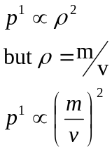
For a fixed mass of gas m is constant 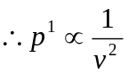

As a result 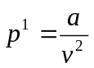 where a = constant
Hence pressure in bulk = 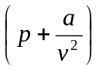

From general equation of state; 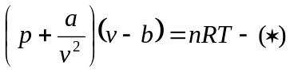
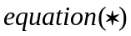 is Vander Waals equation of real gases.
P-V sketches for a gas
- Which obeys Boyle’s law
- Obeys Vander Waals forces
- Which is real practically (experimental curves for real gas)
V

T₃

T₁

T₂

P

(i)
T₁ < T₂ < T₃

B
A
T₃
T₂ = T_{c}
T₁
C
V
P

(ii)

(iii)
P

gas
liquid
B
Liquid
T₃
Saturated vapour
Unsaturated Vapour
A
T₂ = T_{c}
T₃
T₁
V

T_{c} is critical temperature which is temperature above which a gas can not be liquidified.
- At high temperatures, experimental isothermals (curves) , are similar to those in (i) and (ii). Therefore real gases behave as ideal gases at high temperatures.
- As the temperature is reduced, the isothermals in (ii) change in shape. The isothermals in T₂ has an inflexion at C which corresponds to the critical point of a real gas and this is similar to that in figure (iii).
Vander Waals equation roughly applied to real above their critical temperature
- Below the critical temperature, the isothermals in figure (ii) differ from those in figure (iii) e.g. region AB in (ii) implies that pressure increases with volume which is practically impossible. Therefore Vander Waals equation does not hold for real gases below their critical temperature.

State and explain the conditions under which real gases behave as ideal gases.
At high temperatures, the intermolecular forces of attraction for real gases are so weak such that they become negligible thus behaving like ideal gases.
At very low pressures all real gases obey PV=RT just like ideal gases.
Therefore, for a particular container, the gas molecules will then be few (since pressure is low) and much further a part. This implies that the volume of the gas molecules becomes negligible compared to the volume of the container
Examples
1. Helium gas is contained in a cylinder by a gas – tight piston which can be assumed to move without friction. The gas occupied a volume of 1.0 x 10⁻³ m³ at a temperature of 300K and a pressure of 1.0 x 10⁵ pa. Calculate the number of helium atoms in the container.
PV = nRT
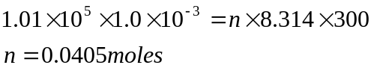
1 mole of helium contain 6 x 10²³ atoms
0.0405moles of helium contain

2. A volume of 0.23m³ contains nitrogen at a pressure of 50 x 10⁵ pa and temperature 300k. Assuming that the gas behaves ideally,
(i) calculate the amount in mole of nitrogen present.
(ii) Calculate the ms speed of nitrogen molecules at a temperature of 300k. (molar mass of
N₂= 0.028kgmol⁻¹)
(i)
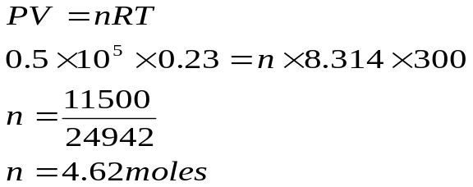
(ii)
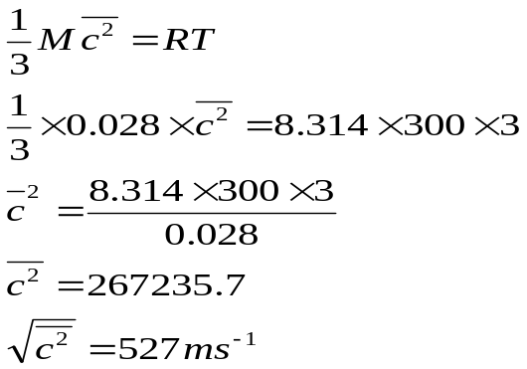

Exercise
1. Calculate the root mean square speed at 0⁰C of (i) hydrogen molecules and (ii) oxygen molecules assuming 1 mole of a gas occupies a volume of 2 x 10⁻² m³ at 0⁰C and 10⁵Nm⁻² pressure. Assuming helium molecules have a 1ms speed of 900ms⁻¹ at 27⁰C and 10⁵ Nm⁻² pressure, calculate the ms speed at (i) 127⁰C and 10⁵Nm ⁻² pressure.
(ii) 27⁰C and 2 x 10⁵Nm⁻² pressure.
2. Two vessels pf capacity 1.0l are connected by a tube of negligible volume. Together they contain 3.4 x 10⁻⁴kg of helium at a pressure of 8cm ltg and temperature 27⁰c. Calculate the pressure developed in the apparatus if one vessel is cooled to 0⁰c and the other heated to 100⁰c, assuming that the heat capacity of each vessel is unchanged.(1.12x10⁵Pa)
3. A container of volume 1.0l contains a mixture of 5g of nitrogen and 5g of hydrogen gas at 293k. Calculate
- The partial pressure exerted by each gas (6.08x10⁶Pa, 4.34x10⁶Pa)
- The root mean square speeds of the gas
(molar masses of H₂ and N₂ are 2 and 28 respectively)
4. Air may be taken to contain 80% nitrogen molecules and 20% oxygen molecules of relative molecular masses 28 and 32 respectively. Calculate.
- Ratio of partial pressure of each in air.(0.25)
- Ratio of mean square speed of Oxygen to that of nitrogen molecules in air (0.875)

Thermodynamics
Work done by an expanding ideal gas
Consider a volume V of the gas confined in a cylinder by a frictionless piston
P,V
P, V+DV
D_{X}

A force F must be applied to keep the volume of the gas constant.
Suppose the gas is allowed to expand to V+∆V at constant pressure, the work done by the gas is ∆W = F∆X, Where ∆X is the distance moved through by the piston.
But F = PA , where A is the cross sectional area of the piston.
∆W = PA∆X
But A∆X = ∆V (change in volume)
∆W = P∆V
Hence for finite expansion from a volume V₁ to a volume V₂, the work done is
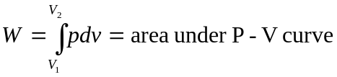
V₁
V₂
P
V

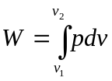

1st law of Thermodynamics
When a quantity of heat, ∆Q is supplied to a gas, that heat may be used by the gas to expand and do work, ∆W or it may be used to increase the internal energy of the molecules, ∆U.
Hence ∆Q = ∆U + ∆W ……………1st Law of thermodynamics

-∆Q = energy removed from system
-∆W = means gas is being compressed hence work done on the gas
+∆W = gas does work, there is an expansion
+∆U = internal energy increases
-∆U = internal energy reduces.
Internal energy
For real gases, the internal energy of the gas is due to the kinetic energy component and the potential energy component.
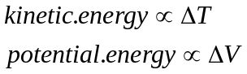
An ideal gas has no intermolecular forces so its internal energy has no potential energy components so the internal energy of an ideal gas is independent of its volume and only depends on its temperature.
Hence, for ideal gases 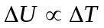

Molar heat capacity at constant pressure (Cp)
The amount of heat required to change the temperature of 1 mole of a gas at constant pressure by 1 Kelvin
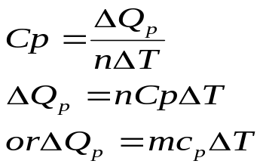
When n = number of moles, ∆T = change in temperature.
Molar heat capacity at constant volume (C_{v})
The amount of heat required to change the temperature of mole of a gas at constant volume by 1 Kelvin.
∆Q_{v} = nC_{v}∆T
From the 1st law of thermodynamics
∆Qv = ∆U + P∆V
Hence ∆Q_{v} = ∆U
∆U = nC_{v} ∆T.

The volume expansion of a metal at constant pressure is very small compared to that of a gas. So the external work done is very small. Hence it follows that there is not much difference between the Specific heat capacity of metal at constant pressure and constant volume.

Relation between Cp and Cv
Relation between Cp and Cv
Consider one mole of an ideal gas heated at constant volume. Its temperature changes by ΔT
ΔW = PΔV = 0 (since ΔV = 0)
T→T+ΔT
Fixed piston

ΔQv = ΔU = CvΔT
ΔU = Cv ΔT………………………………… (i)
Consider one mole of a gas heated at constant pressure such that its volume increase from V₁ to V₂ and the temperature changes by ΔT.

V_{1→}V₂
T→T+ΔT
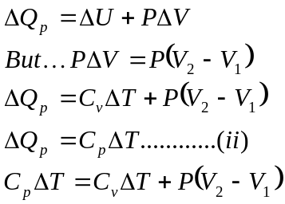

Using the ideal gas equation 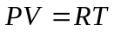
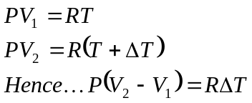
Equation (ii) becomes
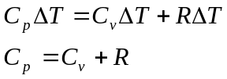
Question
Explain why C_{p} is greater than C_{v}?
Solution
At constant pressure, the heat energy supplied is partly taken in to increase internal energy and also used to do external work. However at constant volume, all the heat energy supplied is taken in to raise the internal energy since no external work is done. Therefore a lot of heat is required to cause a 1K temperature rise.
Particular gas changes
(i) Isovolumetric process (constant Volume,V)
At constant volume, the work done by the gas is zero hence 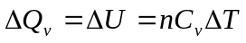
(ii) Isobaric process (constant pressure, P)
At constant pressure
(iii) Isothermal process (constant temperature, T)
At constant temperature, ΔT = 0. hence ΔU =0
Therefore, ΔQ = PΔV. All the heat energy reappears as work done, hence all heat is used to expand the gas.
For an ideal gas PV = nRT
Since T is constant, PV = constant.
Hence Isothermal processes obey Boyle’s law.
From the kinetic theory, if a gas confined in a cylinder by a piston expands, the molecules bounce off the moving away piston with reduced speeds. The mean kinetic energy of the gas and hence the temperature would decrease. Hence for an isothermal expansion, heat must flow into gas to keep the temperature constant. When a gas is compressed with a moving in piston, the molecules of the gas bounce off the piston with increased speed. The mean kinetic energy and hence temperature of the gas would increase. Hence in an isothermal compression, heat must flow out of the gas to keep the temperature constant.
Conditions for realizing an isothermal process in practice.
1. The gas must be contained in a thin walled highly conducting vessel.
2. The vessel must be surrounded by a constant temperature bath.
3. The process must be carried out slowly to allow time for heat exchanges.
Reversible isothermal change
Suppose a gas expands isothermally from a state (P₁, V₁, T) to a state (P₂, V₂, T). If the change can be reversed so that the gas can be returned to the state (P₁, V₁, T) through identical steps as were taken in going from state (P₁, V₁, T₁) to state (P₂, V₂, T), then the change is said to be reversible.
Hence from the graph below process AB is reversible if B changes to A through the same path.
P
P₂
P₁
V₁
V₂
V
A(P₁, V₁, T)
B(P₂, V₂, T)

Work done by a gas in an isothermal expansion
P
V₁
V₂
V
δv

Suppose the volume of the gas changes by δV at an average pressure P, the work done by the gas δW = PδV = area of the shaded region.
Hence the total work done when the gas expands isothermally from V₁ to V₂ is
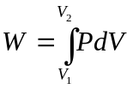
For n moles of an ideal gas PV = nRT, hence 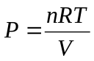
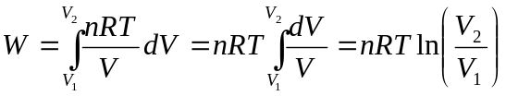
Hence work done during isothermal expansion, 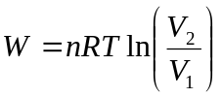
But 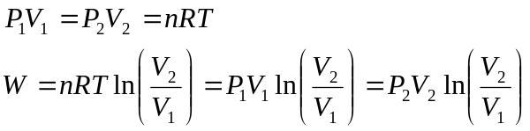
(iv) Adiabatic process
In this process, no heat enters nor leaves the gas system. Hence ΔQ =0
Hence from 1st law of thermodynamics 0 = ΔU +ΔW
- -ΔU =ΔW,
ΔU = -ΔW
When the gas expands adiabatically, the gas does work at the expense of the decrease in internal energy. Hence the temperature of the gas decreases.
In adiabatic compression, internal energy increases as the work is done on the gas. Hence the temperature of the gas increases. This can be perceived when operating a bicycle pump; the pump warms up (Adiabatic compression). When you allow air to move out of a valve of a tube or car tyre, the air feels cold (Adiabatic expansion).
Conditions for realizing an Adiabatic process in practice
1. Gas must be contained in a thick- walled perfectly insulated container.
2. The process must be carried out rapidly.
Equations of reversible Adiabatic changes
(i)
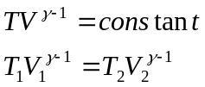 where 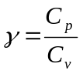
(ii) 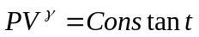
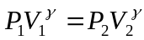
Examples
1. Nitrogen gas, in an expandable container is raised from 0°C to 50°C at a constant pressure 4x10⁵Pa. The total heat added is 3.0x10⁴J. Find (i) the number of moles of the gas
(ii) the change in internal energy of the gas
(iii) the work done by the gas ( C_{p} = 29.1Jmol⁻¹K⁻¹)
Solution
(i)
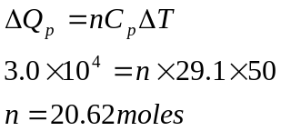
(ii) 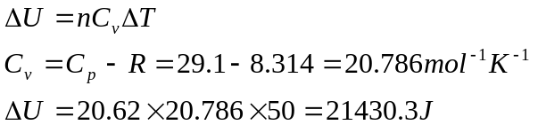
(iii) 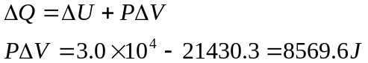

2. The density of a gas is 1.775kgm⁻³ at 27°C and 10⁵Pa pressure and its specific heat capacity at constant pressure is 846Jkg⁻¹K⁻¹. Find the ratio of its specific heat capacity at constant pressure to that at constant volume.
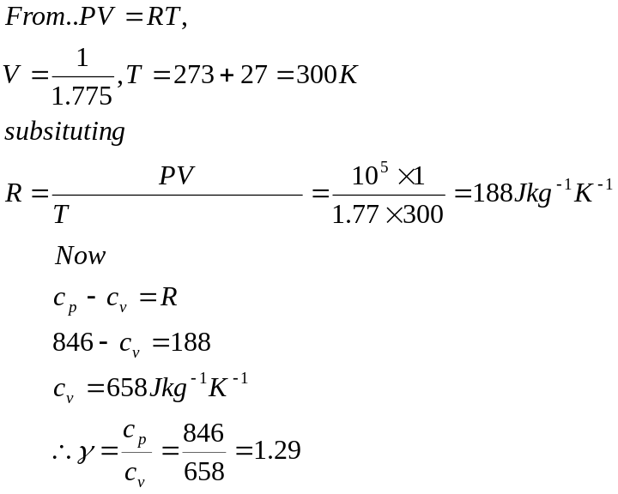
- A vessel containing 1.5x10⁻³m³ of an ideal gas at pressure of 8.7x10⁻²Pa and temperature 25°C is compressed isothermally to half its volume and then allowed to expand adiabatically to its original volume. (γ =1.41)
- Calculate the final temperature and pressure
- Calculate the work done during the isothermal process.
P
P₂
P₁
V₂
V
A
B
P₃
C
T₁
T₂

V₁

From the graph above, motion AB is isothermal, hence applying Boyle’s law
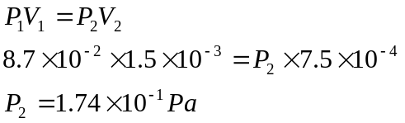
Process BC is adiabatic, hence
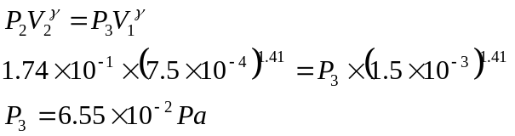
Hence final pressure is 6.55x10⁻²Pa
To find final temperature, consider process BC
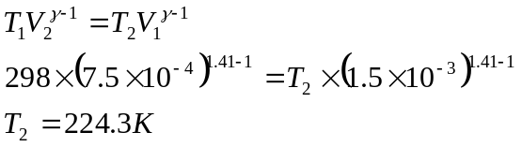
(ii) Work done during the isothermal compression
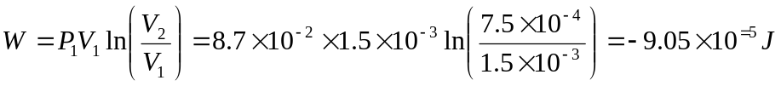

Exercise
1. A cylinder contains 4kmoles of Oxygen gas at a temperature of 47°C. The cylinder is provided with a frictionless piston which maintains a constant pressure of 1x10⁵Pa. The gas is heated until its temperature is increased to 147°C. ( C_{p} =29.41Jmol⁻¹K⁻¹,
R = 8.31Jmol⁻¹K⁻¹ )
Calculate (i) the Amount of heat supplied to the gas (1.176x10⁷J)
- The change in internal energy.( 8.436x10⁶J)
- One litre of a gas at a pressure of 1.0x10⁵Pa and temperature of 17°C is compressed isothermally to half its volume. It is then allowed to expand adiabatically to its original volume. Calculate the final temperature and pressure. (γ = 1.40) (Final pressure = 7.57x10⁴Pa, final temperature =219.8K)
- An ideal gas at a pressure of 2.0x10⁶Pa occupies a volume of 2.0x10⁻³m³ at 47.5°C. The gas expands adiabatically to a final pressure of 110x10⁵Pa. ( = 1.40)
Calculate (i) the number of moles of the gas (1.5 moles)
(ii) The final volume (5.92x10⁻⁴m³)

SATURATED AND UNSATURATED VAPOURS
Evaporation
Condensation
Fixed piston
Liquid

Consider a liquid confined in a container with fixed piston.
In the confined space above liquid, two processes take place. These are evaporation( the most energetic molecules have sufficient kinetic energy to overcome the attraction by other molecules and leave the surface of the liquid to become vapour molecules) and condensation ( the vapour molecules collide with the walls of the container giving rise to vapour pressure and also bombard the surface of the liquid and re-enter the liquid).
In an unsaturated vapour, the rate of evaporation is greater than the rate of condensation in a saturated vapour, the rate of evaporation is equal to the rate of condensation and there is dynamic equilibrium between liquid and its vapour. At a given temperature, the saturated vapour has a maximum density at that temperature and the vapour exerts a maximum vapour called saturated vapour pressure (S.V.P).
Saturated vapour can be defined as the vapour in contact with its own liquid or it is the vapour which is in dynamic equilibrium with its own liquid. Unsaturated vapour is the vapour which is not in contact with its own liquid.

Effect of volume on S.V.P
If the volume of the space above the liquid is increased at constant temperature. There is a momentary decrease in the density of the vapour. The rate of condensation decreases and more liquid evaporates until dynamic equilibrium is restored.
Hence, volume changes has no effect on saturated vapour pressure(S.V.P) i.e. saturated vapour pressure is independent of volume at constant temperature.
If the increase in volume is continued, more and more liquid evaporates until there is none left. The vapour becomes unsaturated.

Saturated vapour
Unsaturated vapour
Pressure
S.V.P
Volume

Saturated vapour does not obey Boyle’s law but unsaturated vapour do.

Effects of temperature on SVP
Increase in temperature increases the kinetic energy of liquid molecules and also of the vapour molecules. Hence both the rate of evaporation and the rate of condensation increases.
The dynamic equilibrium is achieved at higher saturated vapour pressure since a higher vapour density is obtained eventually all the liquid evaporates and the vapour becomes unsaturated. Increase in temperature, increases saturated vapour pressure
Saturated vapour
Unsaturated vapour
Temperature
Pressure

Unsaturated obeys pressure law whereas saturated don’t. Since saturated vapour do not obey either Boyle’s or pressure law, they can not obey the equation of state hence never apply 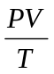 = constant to saturated vapours. However the equation of sate can be applied to unsaturated vapour.

Measurement of SVP of a liquid
In the figure below, C is a large chamber acting as a buffer against pressure variations and keeping h steady.
The pressure in the chamber C is adjusted to a suitable value by opening the clip D, and pumping air on the system and then closing D. The liquid in the flask is heated until it boils. The reflex condenser, condenses the vapour and return it flask.
When cooling occur, the SVP = atmospheric pressure – h. The boiling point is read from the thermometer. The procedure is repeated for different values of h. the corresponding boiling point ( θ°C) are determined.
h
Heat source
Cold water
C
Condenser
D

A graph of SVP vessel θ°C can be plotted.
SVP
76cmHg

100°c
θ°C

We note that at low temperature, a large change in temperature leads to a small change in SVP.
Examples
A closed vessel contains air and little water. The temperature of water is 20⁰C and the pressure in the vessel is 76cmHg. Calculate the new pressure when the temperature of the vessel is raised to 40⁰C, water still being present. (S.V.P of water at 20⁰C and 40⁰C = 2.0cmHg and 8.0cmHg respectively)
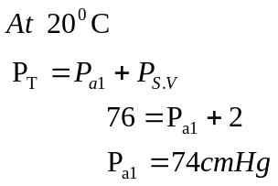
At 40⁰c
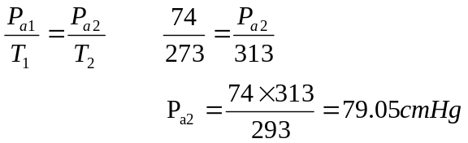

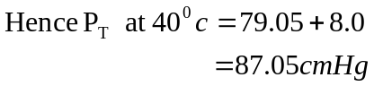

2. A column of nitrogen is trapped in a capillary tube of constant X sectional area and closed at one end by a thread of water.
Water index
L

Nitrogen

The length of nitrogen column is 20.0cm at 25⁰c and 25.2cm at 83.3⁰c.
Calculate the saturated vapour pressure of water at 83.3⁰c if its value at 25⁰c is 1.70 x 10³ Nm⁻², Neglect weight of water thread and assume that atmospheric pressure remain constant and is 1.01 x 10⁵Nm⁻².
At 25⁰c
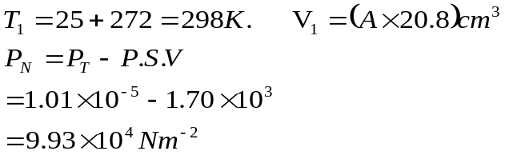

At 83.3°C
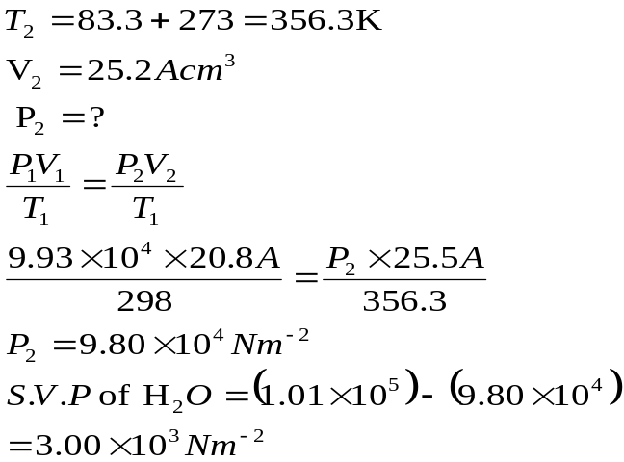

P
Q
Constant temperature bath at 60°C

3. Two vessels P and Q each of volume 1.5cm³ are joined in the middle by a closed tap and placed in the constant temperature both at 60⁰C. P contain a vacuum while Q contains air and saturated water vapour. The total pressure in Q is 200mmHg. When T is opened, equilibrium is reached with the water vapour remaining saturated. If the final pressure in the cylinders is 150 mmHg, calculate the S.V.P of water at 60⁰c.
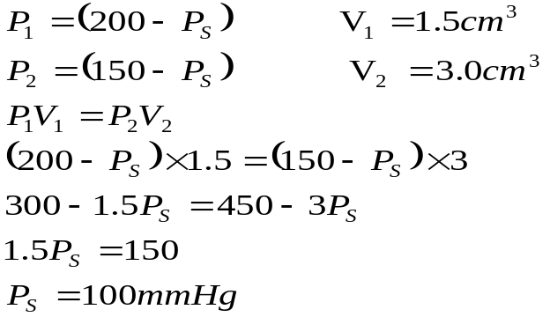

Exercise
1. The air column is trapped in a tube of uniform cross section area and closed by a thread of water. The length 1, of the air column, is column, is 10.0cm at 15⁰C and 12.6 cm at 50⁰C. Calculate the SVP of water at 50⁰C. If the value at 15⁰C is 1.7 x 10³ Pa. (Neglect the weight of the water thread and assume that the atmospheric pressure = 1.01 x 10⁵ Pa) (1.26x10⁴Pa)
2. In a laboratory, a student collected 1000cm³ of hydrogen over water at 20⁰C. The external pressure was 70.0cm of mercury. The S.V.P of water at 20⁰c is 1.76cm of mercury. Calculate the corresponding volume of hydrogen at STP. (836.6cm³)
3. A volume of 4.0 x 10⁻³ m³ of air is saturated with water vapour at 100⁰C. The air is closed at 20⁰C at constant pressure of 1.33 x 10⁵pa. Calculate the volume of air after cooling, if the SVP of water at 20⁰C is 2.3 x 10²Pa.
( Atmospheric pressure = 1.01x10⁵Pa)

4. A horizontal tube of uniform bores enclosed at one end, has some air trapped a small quantity of water. If the length of the enclosed air column is 20cm at 14⁰C, what will it be if the temperature is raised to 40⁰C and atmospheric pressure remains at 760mm of Hg.
(l =23cm)

5. The total pressure in a closed vessel containing air and saturated vapour at 35⁰C is 1.01 x 10⁵Pa. If the saturation vapour pressure is at 35⁰c and 87⁰c are 3.99 x 10³Pa and 7.18 x 10⁴ Pa respectively, calculate the total pressure in the vessel at 87⁰C, assuming the air remains unchanged. (1.852x10⁵Pa)

HEAT TRANSFER
Thermal Conduction
Conduction is the transfer of heat energy from one place to another without the movement of the substance as a whole. When the end of the solid is heated, the amplitude of vibration of the atom of the solid increase. The atoms collide with neighbouring cooler atoms and pass on some of their energy to these atoms. In this way heat is transferred from the hot end to the cool end.
In gases, fast moving molecules pass on kinetic energy to the slower moving ones when they collide with them. In this way heat is slowly conducted through gases.
In metals, the free elections travel at high speeds and transfer energy quickly from one part of the metal to another by collisions with other elections and other atoms. Hence in metals, heat is carried by mainly the motion of free election and by the inter atomic vibration.
In non-metals and liquids, there are no free elections and hence heat is transferred from one atom to another by inter atomic vibration,. This process of heat conducted is slow as compared to that in metals.

Thermal conductivity (Coefficient of Thermal Conductivity, K)
Consider a slab of thickness L and area of cross sections A having temperatures θ₁ and θ₂ at its ends.
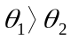
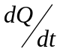

θ₁ θ₂

Experiment shows that the rate of flow of heat through the slab is;
- Proportional to the cross sectional area, A
- Proportional to the temperature drop or difference between the faces, (θ₁-θ₂).
- Inversely proportional to the thickness, L
- Is dependent of the material
Rate of flow of heat,
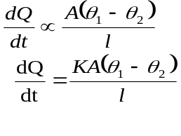
Where K= thermal conductivity or co-efficient of thermal conductivity.
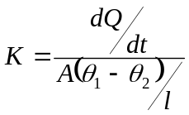
Hence thermal conductivity of a material is the rate of heat flow through the material normal to opposite faces of cross section area 1m² in a region of unit temperature gradient.
Units of K is Wm⁻¹K⁻¹

Temperature distribution along an insulated bar of a good conductor of uniform cross section in steady state
θ₁
θ₂
θ₁
θ₂
Temperature in °C
Length of bar
0
lagging

Since there is no loss of heat to the surrounding, the rate of heat flow 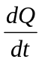is constant hence temperature gradient, 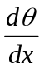,will be constant.

Temperature distribution along an unlagged metal bar

θ₂
θ₁

θ₁

Temperature

θ₂
Length

Determination of thermal conducting K of a good conductor of heat e.g. Cu
The thermal conducting of a good conductor of heat e.g. copper can be obtained using Searle’s apparatus. The specimen bar is heated from one end using a steam jacket and cooled at the other end by circulating water.
l
θ₁
θ₂
θ₄
θ₃
Heater
Water out
B
A

Water in

When the apparatus has been moving for sometime, a steady state condition is attained when,
- The temperature θ_{1,} θ_{2,} θ₃ and θ₄ remain constant.
- The rate of heat flow and the temperature gradient are the same for any section of the bar since it is lagged.
The steady temperatures θ_{1,} θ_{2,} θ₃ and θ₄ are recorded and the mass rate of flow, m of water obtained by collecting the warm water flowing out of B and measuring the mass obtained in a given time.
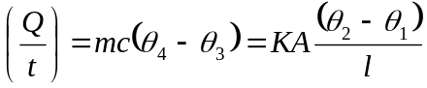
Where c is the specific heat capacity of water, A = area of cross section of bar.
Using:
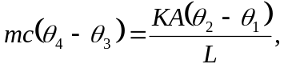 the thermal conductivity K can be calculated
N.B In order not to upset the temperature gradient, the cold water is allowed in through A and not through B

Determination of thermal conductivity K of a poor conductor of heat e.g glass
The specimen is made uniform of a disk D. the disc d is placed on a thick brass slab B containing a thermometer and is heated from above by a steam chest C whose thick base carries a thermometer.
θ₂
θ₁
Steam in
B
D
C
Steam out

The experiment has two parts:
Part 1of the experiment
Steam is passed until the temperature θ₁ and θ₂ are steady. Heat flow from C to B through D and is then lost to the surrounding. At steady state, the rate of heat flow equals the rate of heat loss of B of temperature θ₁ to the surrounding.

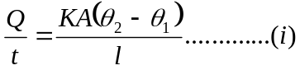
Where A₁, θ_{2,} θ₁ and l are all measured.
Part 2 of the experiment
The disc D is removed and B is heated directly from C until its temperature is above want it was in part 1. C is then removed and a thick felt pad is placed on top of B. Temperature and corresponding time readings are recorded as B cools and a cooling curve is plotted. The aim of part 2 is to find the rate of heat loss from B at temperature θ₁
Temperature
Cooling curve

θ₁
a

b
Time

the rate of temperature fall of B at θ₁, equals the slope 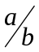of the tangent at θ₁
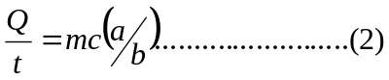
Where m = mass of the brass slab B, c = specific heat capacity of brass
Since the rate of heat loss from B depends on the temperature of B (which is the same in the two parts) then 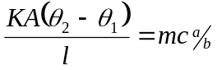
The thermo - conductivity K can then be calculated.
Note: In determination of thermal conductivity of a poor conductor such as card board or ebonite, the substance is made thin in order to get an adequate rate of heat flow and fairly of large surface area to reduces the heat loss to the surroundings from the specimen.

Examples:
1. Uniform composite slab is made of two types of material A and B of thickness 6cm and 3cm and of thermal conductivities 369Wm⁻¹k⁻¹ and 120 Wm⁻¹k⁻¹ respectively. If the ends of A and B are maintained at 80°C and 20°C, calculate
- The temperature of the junction of the two materials
- The rate of flow of heat through an area of 1m² of the slab.
20°C
80°C
θ
A
B

Rate of heat flow through A 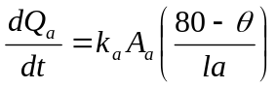

Rate of heat flow through B 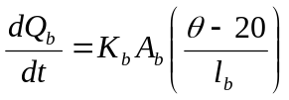
If heat is to flow rates should be equal
Rate of heat flow through A = Rate of heat flow through B

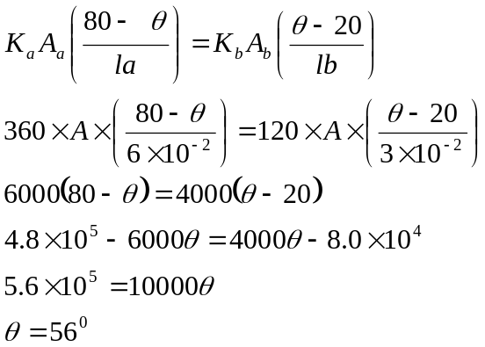
Rate of heat flow = 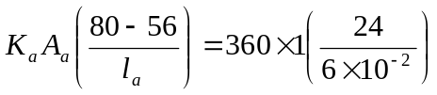
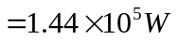
2. A wall 6m x 3m consists of two layers A and B of bricks of thermal conductivities 0.6 and 0.5 Wm⁻¹K⁻¹ respectively. The thickness of each layer is 15.0cm. The inner surface of layer A is at a temperature of 20⁰C while the outer layer of B is at temperature of 10⁰C. Calculate
- The temperature of the interface of A and B
- The rate of heat through the wall
0.15m
0.15m
20°C
10°C
A
B
θ

A= 6 X 3 = 18m²
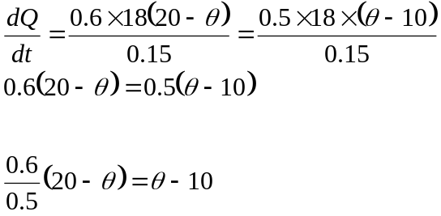
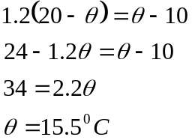
(ii) Rate of heat flow,
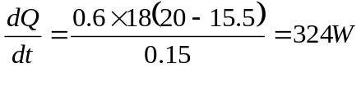

Exercise
1. A wall consists of two layers of thickness L₁ and L₂ and thermal conductivities k₁ and k₂ respectively. If the surfaces of the wall are maintained at temperatures T₁ and T₂. Show that the rate of heat transfer through the wall is
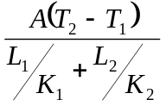 Where A is the area
- State the assumption made above
- A cooking utensil of thickness 3mm is to be made of two layers, one of aluminium and the other of brass. If one layer is to be 2mm thick and the other 1mm, determine which combination allows a higher rate of flow.

2. The external walls of a house consist of two layers of brick separated by an air cavity. The outer face of the wall is at a temperature of 45°C while the inside of the house is at 20°C. If the thickness of each brick layer is 15cm and air cavity is 5cm, calculate the temperature of the walls in contact with the cavity.

3. Water in an aluminium saucepan of diameter 16cm and thickness 4mm is kept boiling at 100°C in the Stove. The water boils at a rate of 2.28 x 10⁻⁴ kgs⁻¹. Calculate the temperature of the underside of the saucepan.(100.5°C)

4. A window of height 1.0m and width 1.5m contains a double glazed unit consisting of two single glass planes, each of thickness 4.0mm separated by an air gap of 2.0mm. Calculate the rate at which heat is conducted through the window if the temperature of the external surfaces of glass are 30°Cand 20°C (K of glass = 0.72 Wm⁻¹k⁻¹ , K of air = 0.025 Wm⁻¹k⁻¹ )
5. One end of a perfectly lagged metal bar of length 0.10m and cross sectional area 5x10⁻⁴m² is maintained at 100°C while the other is in contact with ice. Calculate the rate at which the ice melts. ( Thermal conductivity of the metal is 400Wm⁻¹K⁻¹, specific latent of fusion = 3.36x10⁵JKkg⁻¹) ( 5.95x10⁻⁴kgs⁻¹)

RADIATIVE TRANSFER
This is the transfer of heat radiation from place to place without the need for the interning medium. It is the mechanism by which heat radiation propagates in a vacuum.

Electromagnetic spectrum
The term radiation covers a wide spectrum from the very short length Y –rays to the very long, ware length radio waves.
The variation of wave length across the electromagnetic spectrum is illustrated below

Radiation | γ-rays | X-rays | Ultra-Violet | Visible light  Violet Red | Infra-red | Micro-waves | Radio- waves
Wavelength(m) | 10¹² | 10⁻¹⁰ to 10⁻⁸ | 10⁻⁸to 0 ⁻⁷ | 4 x 10⁻⁷ 7.5 x 10⁻⁷ | 10⁻⁶ to 10⁻³ | 10⁻³ to 10⁻¹ | 10⁻¹ to 10⁴m

Detection of infrared radiation
Thermopile
This is a pile of thermocouples arranged as shown schematically below
Cold junction
G
Sensitive galvanometer
Hot junction

The pile of thermocouple is connected to a sensitive galvanometer G. The thermoelectric emf developed in proportional to the temperature difference between the hot and cold junctions.
In dynamic equilibrium, the infrared radiation incident per second on the hot junction is equal to the rate of heat loss to the surrounding by the hot junction. But the rate of loss of heat to the surrounding is proportional to the excess temperature above the surroundings.
Hence, the thermoelectric emf is proportional to the rate of incidence of infrared radiation of the thermopile. The thermopile has the disadvantage that it integrates infrared radiation from a large area

PREVOST’S THEORY OF HEAT EXCHANGE
- A body radiates heat radiation at a rate which is determined by the nature of its surface and its temperature.
- A body absorbs heat energy at a rate which is determined by the nature of its surface and the temperature it’s surrounding.
- A body at constant temperature radiates heat energy at the same rate as it absorbs heat.
It follows from Prevost’s theory, that if the surface of a body is a good absorber of radiation then it must be equally a good emitter, otherwise its temperature would rise above that of its surrounding. Black and rough surface are better absorbers and emitters of radiation.
Black body radiation
When radiation falls on a surface, three things happen, that is:
    - A certain amount of heat R is reflected,
    - A certain amount of heat A is absorbed,
    - A certain amount of heat T is transmitted.
T
R
A
I

I = A + R + T

For a black surface, no reflection or transmission occurs. All the radiation incident on it is absorbed. Hence a black body is one which absorbs all the wavelengths of the radiation in incident on it and transmits or reflects none.
An approximation of a black body consists of a hollow sphere whose inside is coated with black rough material and a small hole for admission of radiation into the cavity.

At each reflection inside the cavity, a certain percentage of the radiation is absorbed. Eventually after multiple reflections all the radiation is absorbed.
A device like this which absorbs all the radiation incidents on it is known as a black body.
Black body radiation is that radiation whose quality (wave length) depends only on the temperature of the body. It is sometimes called full radiation or cavity radiation or temperature radiation.
Spectral curves for black bodies
Wavelength, λ
Relative Intensity
Visible light
T₁
T₂
T₃
T₁< T₂< T₃

Intensity, E is the radiant energy emitted per second, per metre squared or it is the power incident on a unit area, or power emitted by metre squared.
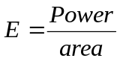
Relative intensity, E_{λ} is the power radiated per metre squared of a black body in a unit wavelength interval.
Relative intensity 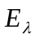= 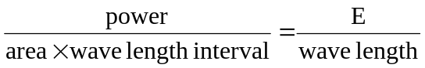
Features of the graph
- As the temperature increases the intensity of every wave length increases but the intensity of the shorter wave lengths increase more rapidly.
- The wavelength at which maximum intensity occurs shifts to shorter wave lengths as the temperature increases.
The appearance of the body depends on the position of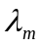(Wavelength at which maximum intensity occurs). The body changes from its colour when cold, to red hot (is in the red region of the specimen) to yellow hot, white hot ( is in the middle of the spectrum, to blue hot ( in the blue region).
Laws of Black Body Radiation
1. The wavelength at which the intensity is maximum for a temperature (T) is such that T = constant. The constant = 2.9 x 10⁻³mk. This is called Wien’s Displacement Law
2. The total power radiated per metre squared (intensity) of the black body at absolute temperature T is proportional to T⁴.
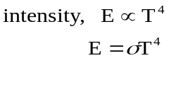………….Stefan’s Boltzman’s law
σ is constant called Stefan’s constant
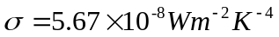

Cooling of bodies
Suppose a hot sphere with surface area A and temperature, T_{h} is placed in a cold enclosure with temperature, T_{c}. If the body is a black body, the rate of absorption of heat 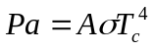 and the rate of emission 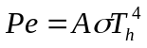
Hence power radiated = 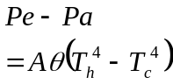

Examples
1. Calculate the rate pf loss of heat energy of a black body of area 40m² at a temperature of 50°C, if the radiation it receives from the sun is equivalent to a temperature in space of
-220°C.
T_{c} = -220 +273 = 53K
T_{h} = 50 +273 = 323K
Rate of heat loss
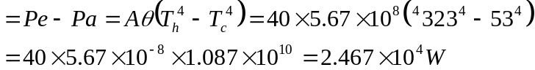

2. The element of an element fire has a temperature 1150K. Calculate the frequency at which the intensity of the radiation by the element is maximum.
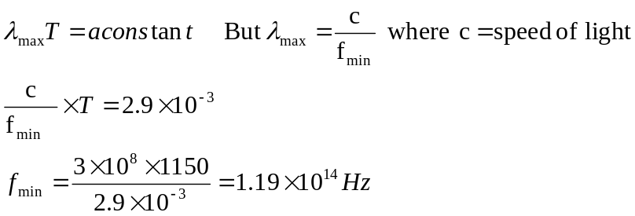

3. A copper wire of length 130.2cm, diameter 0.0326 cm is blackened and placed along the axis of an evacuated glass tube. The wire is connected to a battery, a rheostat, an ammeter, and a voltmeter. The current is then increased until the ammeter reads 12.8A and voltmeter 20.2V. At this point the wire is about to melt.
(i) Draw diagram of the circuit
(ii)find the Melting temperature of the copper
v
A

Melting temperature of Cu
l

Radiating surface area = 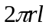
Heat generated P = VI
Power radiated = 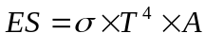 (assuming the wire radiated as a black body)

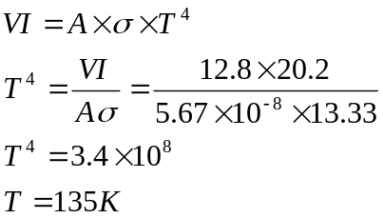
Exercise
A solid copper sphere of diameter 10mm is cooled to a temperature of 150k and is then placed in an enclosure maintained at 290k. Assuming that all the interchange of heat is by radiation; calculate the initial rate of rise in temperature of the sphere. The sphere may be assumed to behave as a black body.( Density of copper = 8.93 x 10³kgm⁻³, specific heat capacity = 370Jkg⁻¹K⁻¹)

ESTIMATING TEMPERATURE OF THE STARS
Assume the sun to be a sphere of radius r_{s} having a temperature T_{s} and radiating as a black body. The power radiation by the sun,
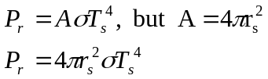
The power is radiated in all directions
Earth
Imaginary sphere

R = r_{s} + R_{es}

Intensity at the earth surface = 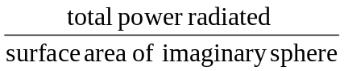
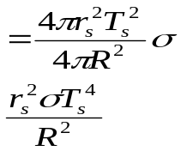
Intensity at the earth’s surface is called solar constant
Power received by the earth = 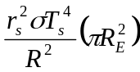
Where 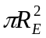 is the area of earth on which the sun’s radiation is incident normally.

1. Estimate the temperature of the earth assuming it is in radiative equilibrium of the sun.
(r_{s} = 7 x 10⁸m, Surface temperature of sun = 6000K, distance from the earth to the sun = 1.5 x 10¹¹m, 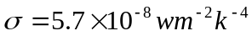)
Power reached by earth = solar constant x area
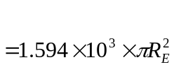
Using Stefan’s law,
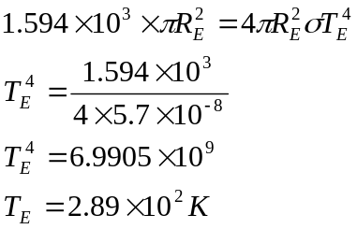

2. Assuming that the sun is a sphere of radius 7 x 10⁸m, at a temperature of 6000k, estimate the temperature of the surface of mars if its distance from the sun is 2.28 x 10¹¹m.
Solar constant for mass =
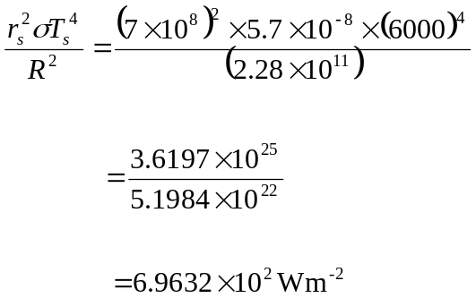
Power reached by mass = solar constant x area
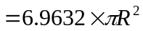
Using Stefan’s law
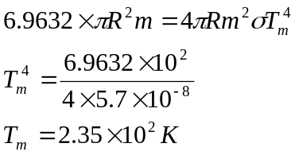
Exercise
1. The total output of the sun is 4.0 x 10²⁶W. Given that the mass of the sun is 1.97 x 10³⁰kg and its density is 1.4 x 10³ kgm⁻³, estimate the temperature of the sun, state any assumptions made (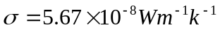) (5.84x10³K)

